- Develop a java program to create class student with members, USN and Name. Include method to accept and display student display create multiple student object and display there information.

import java.util.Scanner;
class Student
{
String USN;
String Name;
void accept()
{
Scanner sc=new Scanner(System.in);
System.out.println("Enter USN:");
USN=sc.nextLine();
System.out.println("Enter Name:");
Name=sc.nextLine();
}
void display()
{
System.out.println("USN : " +USN);
System.out.println("Name : "+Name);
}
}
class StudentRun
{
public static void main(String a[])
{
Scanner sc=new Scanner(System.in);
System.out.println("Enter number of student: ");
int n=sc.nextInt();
Student s[] = new Student[5];
for(int i=0; i<5; i++)
{
s[i]=new Student();
s[i].accept();
}
for(int i=0; i<5; i++)
{
s[i].display();
}
sc.close();
}
}
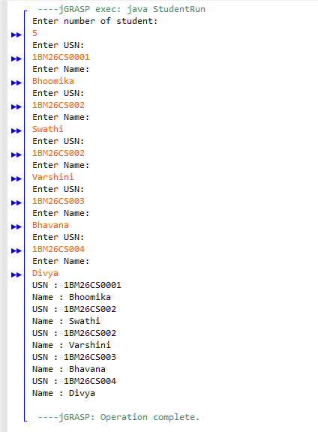

Name: Bhoomika
USN: 1BM26CS456-T

